# SQL Database – Set firewall client IP for SQL Server

**Prerequisites**

* Azure account.

Now, let's get started with the steps, given below-  
  
Create a new Azure SQL Server-level Firewall.  
  
**Step 1-**Sign in to the online [Microsoft Azure Portal](https://portal.azure.com/).  
  
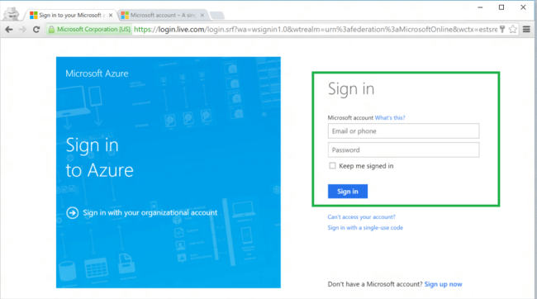  
  
**Step 2-**In the dashboard, click SQL Servers.  
  
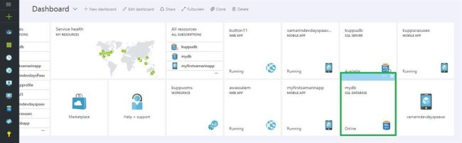  
  
**Step 3-** Next, on SQL Servers blade, click the Server on which Firewall rule is to be created.  
  
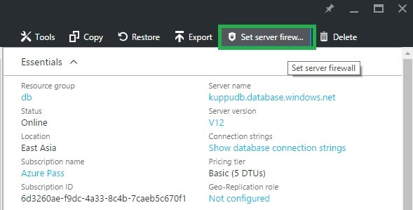  
  
**Step 4-** Now, click Add client IP to have Azure create a rule for your client IP address.  
  
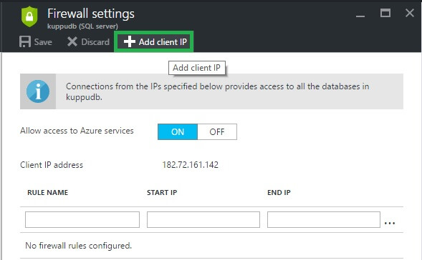  
  
**Step 5-** Finally, click Save to create the Server-level Firewall rule.  
  
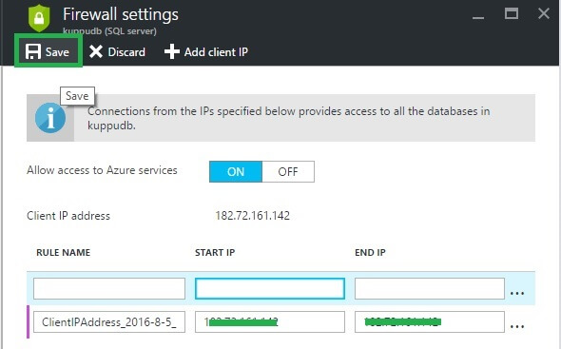  
  
Optionally, to allow access to a range of IP addresses, click the IP address, which was added to edit Firewall address.  
  
**Summary**In this article, we discussed, how to create new Azure SQL Server-level Firewall, using Azure Portal.